Origin of Life (Carolina Biological)
Imagine that you are a scientist interested in studying the origin of life in a lab setting. This has never been accomplished before, but you have experimented and developed a method to create coacervates, droplets of organic polymers that possess life-like characteristics. You intend to create coacervates by adding a carbohydrate solution to a protein solution, as the Russian scientist Alexander Oparin did during the early 20th century. You will use a carbohydrate, gum arabic, and a protein, gelatin.
Background
The origin of life has not yet been duplicated in the laboratory, but several models describe key steps in the process. The most famous of the models have been derived from the experiments performed by Oparin and Haldane, Miller and Urey, and Sidney Fox.
Oparin and Coacervates Alexander Oparin and J.B.S. Haldane, in the 1920s, predicted that the first life forms originated in an acidic primordial sea. This idea has come to be known as the Oparin-Haldane hypothesis. Oparin predicted that organic molecules became increasingly complex through a series of chemical reactions, eventually forming aggregates, or coacervates in an aquatic environment. Oparin created coacervates by mixing different solutions of organic macromolecules under specific conditions in the lab. He found that these spherical objects were enclosed by a selectively permeable membrane composed of organic macromolecules. In this laboratory activity, a solution of gum arabic is added to a solution of gelatin to form coacervates. Gum arabic is made up of carbohydrate macromolecules. Gelatin is made up of protein macromolecules.
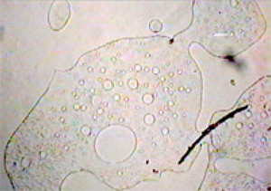
http://www.hccfl.edu/media/383250/lab_02_preparation_of_coacervates-2.jpg
The Miller-Urey Model The Oparin-Haldane hypothesis inspired the famous experiment by Stanley Miller and Harold Urey in 1953. The Miller-Urey model recreates the possible conditions of Earth's early atmosphere and primordial sea. The atmosphere of primitive Earth was mostly composed of volcanic vapors, such as methane, ammonia, and hydrogen. These gases would have dissolved into the primordial sea, causing the water to become acidic. The atmosphere would not become oxygenated until cyanobacteria and other photosynthesizers evolved. There was intense UV radiation, along with frequent lightning strikes and meteorite impacts on the Earth's surface. In the experiment undertaken by Miller and Urey, water simulates the primitive sea. The water is heated and evaporates from a flask into a chamber containing methane, ammonia, and hydrogen. The chamber is sparked, simulating the lightning storms in the early atmosphere, and then the gas is condensed into a liquid and collected. Miller and Urey found that the resulting solution changed from colorless to murky brown. The solution was found to contain organic molecules, including some amino acids found in living organisms. From this experiment, Miller and Urey hypothesized that organic monomers were formed through the reactions of water with gases in the atmosphere and returned to the Earth in the form of rain.
Sidney Fox and Proteinoids In the 1960s, Sidney Fox abiotically synthesized organic polymers such as polypeptides by dripping dilute solutions of organic monomers over hot sand, clay, or rock. This method mimics the condensation of the Miller-Urey model, but with the idea that rain falling from the early atmosphere or waves washing onto hot substrate would be favorable to the formation of polypeptides and other organic polymers. Once these polymers have formed, they can form aggregates, which spontaneously form into proteinoids. Proteinoids, along with coacervates, are protobionts, the closest structures to living organisms that scientists have been able to recreate in the laboratory. Protobionts display a few, but not all, of the properties of life.
Pre Lab Questions:
- What are the characteristics of life?
- Describe one hypothesis about how living organisms arose on Earth.
Materials:
gum Arabic solution, capped tube of gelatin solution, 0.1 M hydrochloric acid, pH paper
graduated cylinder, stirring rod, pipet, microscope slides & coverslips

Procedure:
1. Measure 4 mL of the gum arabic solution in the graduated cylinder.
2. Pour the gum arabic solution into the glass tube containing the gelatin solution.
3. Place the cap on top of the glass tube and gently invert the tube two or three times to mix the solutions. (Vigorous shaking can prevent coacervates from forming.)
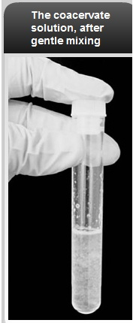
4. Observe the coacervate solution. What color is it? Is it clear or cloudy? Is there a precipitate in the solution?
5. Dip the stirring rod into the solution in the glass tube and then touch the stirring rod to a piece of pH paper.
6. Determine the pH of the solution by comparing the pH paper to the key.
7. Design a data table to organize the measurements you collect. Over five runs, you will record the number of hydrochloric acid drops added to the solution, pH, concentration of hydrogen, observations of the solution, and number of coacervates.
8. Use the pipet to place 1 or 2 drops of the solution onto a microscope slide. Add a coverslip and observe the solution under a microscope on low power.
9. Count the number of coacervates you observe on the entire slide. Coacervates are spherical and can be identified on the slide as circles with darkly outlined membranes.
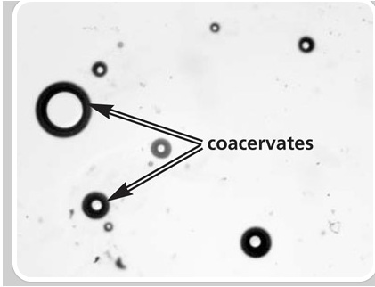
10. Add 1 drop of 0.1 M hydrochloric acid to the glass tube. Place the cap on the tube, hold your finger over the end, and gently invert two or three times. Record your observations.
11. Repeat steps 4–10 until you have prepared and observed five slides of the coacervate solution.

Analysis:
- Calculate the total magnification you used to view the coacervates
- Calculate the field of view (in micrometers) you used to view the coacervates
- Use the field of view measurement to estimate the size of coacervates you observed at the pH at which they were most abundant. The size of an average prokaryotic cell is about 1–3 μm, and the average eukaryotic cell is about 20 μm. How does the size of the coacervates compare with the size of prokaryotic and eukaryotic cells?
- Construct a graph using the pH and the number of coacervates. Title the graph and supply the following information:
  - The independent variable is:
  - The dependent variable is:
- Plot the independent variable on the x-axis, and the dependent variable on the y-axis

Laboratory Questions:
- At which pH were the coacervates most abundant?
- Describe any shared characteristics you observed between coacervates and living organisms
- What type of organic molecule is gelatin? Gum arabic? What is the function of these types of organic molecules in unicellular organisms?
- Why are cells considered a necessary precursor to life?
- Based on the results of this experiment, why would pH have been important in the origin of life?
On the basis of what you learned in the Guided Activity, develop a question to test about coacervates. In developing an experimental question, consider the materials and equipment available to you. Consult your instructor for the availability of additional supplies.
Additional Materials:
0.1 M sodium hydroxide, egg albumin, Alcohol, sodium sulfate, hot water bath, ice, Congo red stain, Sudan III stain, thermometer,other materials as available

Procedure
1. In your group, collaborate to come up with a testable question about coacervates. If you have trouble, ask your teacher for guidance.
2. Design an experiment to test your question. Consider the following as you frame your experiment: • Question - What are you testing in your experiment? What are you trying to find out?
• Hypothesis - What do you think will happen? Why do you think so? What do you already know that helps support your hypothesis?
• Materials - What materials, tools, or instruments are you going to use to find out the answer to the question?
• Procedure - What are you going to do? How are you going to do it? What are you measuring? How can you make sure the data you collect are accurate? What are the independent and dependent variables in this experiment? What is your control? What safe practices do you need to use?
• Data Collection - What data will you record, and how will you collect and present it? Show and explain any data tables and graphs that you plan to use.
3. Have your teacher approve your experimental plan before you begin the experiment.
4. After you perform the experiment, analyze your data:
• Data Analysis - What happened? Did you observe anything that surprised you? Show and explain any tables and graphs that support your data.

• Conclusion - What conclusions can you draw from the results of your experiment? How does this compare with your initial hypothesis? Identify some possible sources of error in your experiment. If given the opportunity, how might you conduct the experiment differently?
Be prepared to present the findings of your experiment to the class according to your instructor's specification.
Part A: To be completed and approved before beginning the investigation
What question will you explore?
On the basis of your previous laboratory exercise, background knowledge, and research, what is the hypothesis that you will test?
What will be the independent and dependent variables?
What will be the control group(s)?
What equipment and materials will you need (list items and quantity)?
What procedure (step-by-step) will you follow?
What safety steps will you follow (equipment and procedures)?
How will you collect data?
How will you analyze data?
Teacher approval to begin your investigation:
Part B: To be completed during or after your investigation
What changes or modifications have you made to the investigation?
Include any data collection or analysis as instructed by your teacher. What results did you see in the experiment?
Was the hypothesis accepted or rejected? What conclusions can you draw on the basis of the data and analysis?
What sources of error may have existed, and how might the experiment have been conducted differently? What additional questions arose from the experiment?
Make a graph to represent your data. Are there any appropriate statistics to include in your analysis?
Big Idea Assessments
- It is assumed that the origin of living things can be explained by natural processes. Describe the conditions on Earth and the natural processes that are believed to have contributed to the origin of life.
- There are causal models about the origin of life on Earth. Explain the term “scientific model” and then describe two models about the origin of life on Earth.

